# CS 255 System Design Document Template

This template lays out all the different sections that you need to complete for Project Two. Each section has guidance to prompt your thinking. You will need to continually reference the interview transcript as you work to make sure that you are addressing your client’s needs. There is no required length for the final document. Instead the goal is to complete each section based on what your client’s needs are. Remove this note when you are finished, and replace all bracketed text with the relevant information.

## UML Diagrams

### UML Use Case Diagram

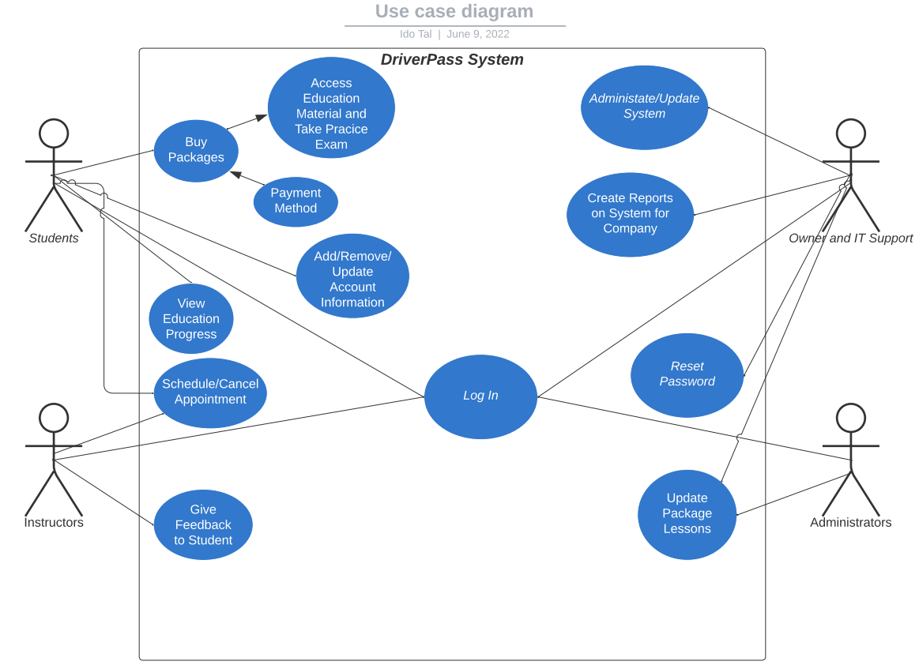

### UML Activity Diagrams

**Purchase Packages UML Activity Diagram:**

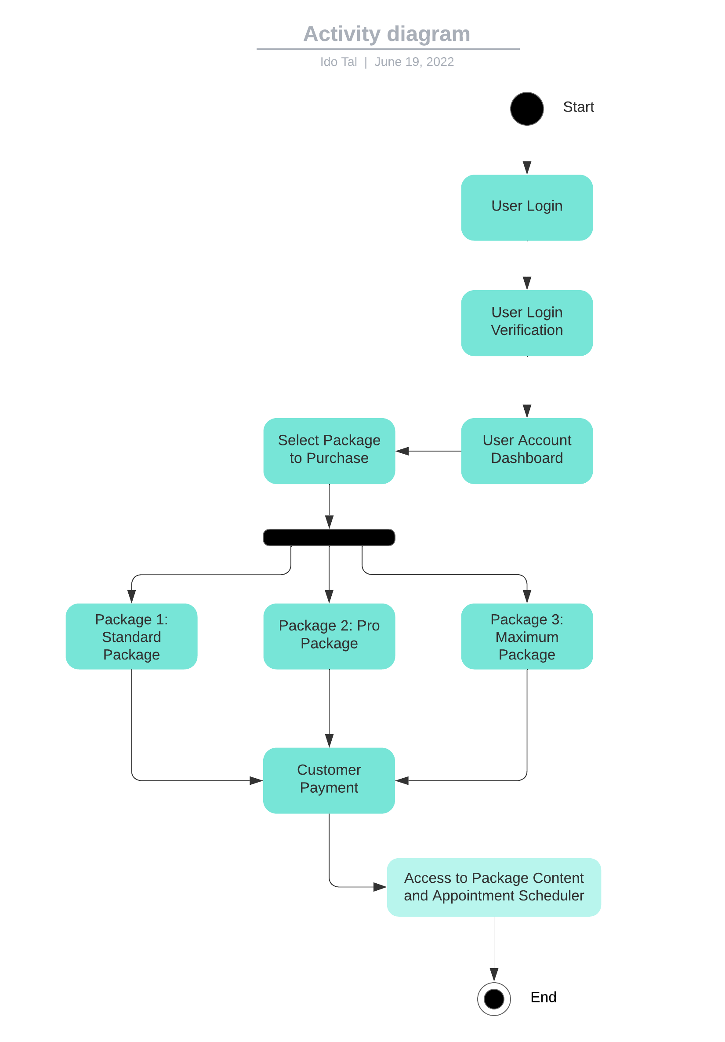

### Reset Password UML Activity Diagram:

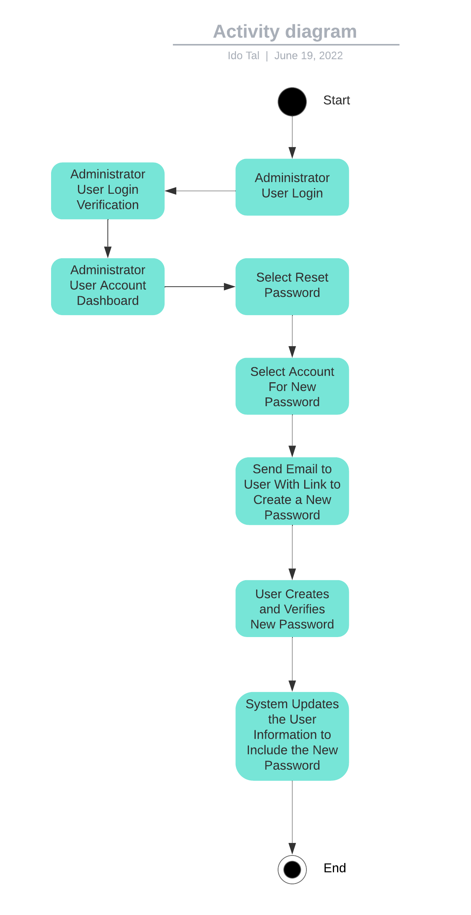

### UML Sequence Diagram

**Purchase Packages UML Sequence Diagram:**

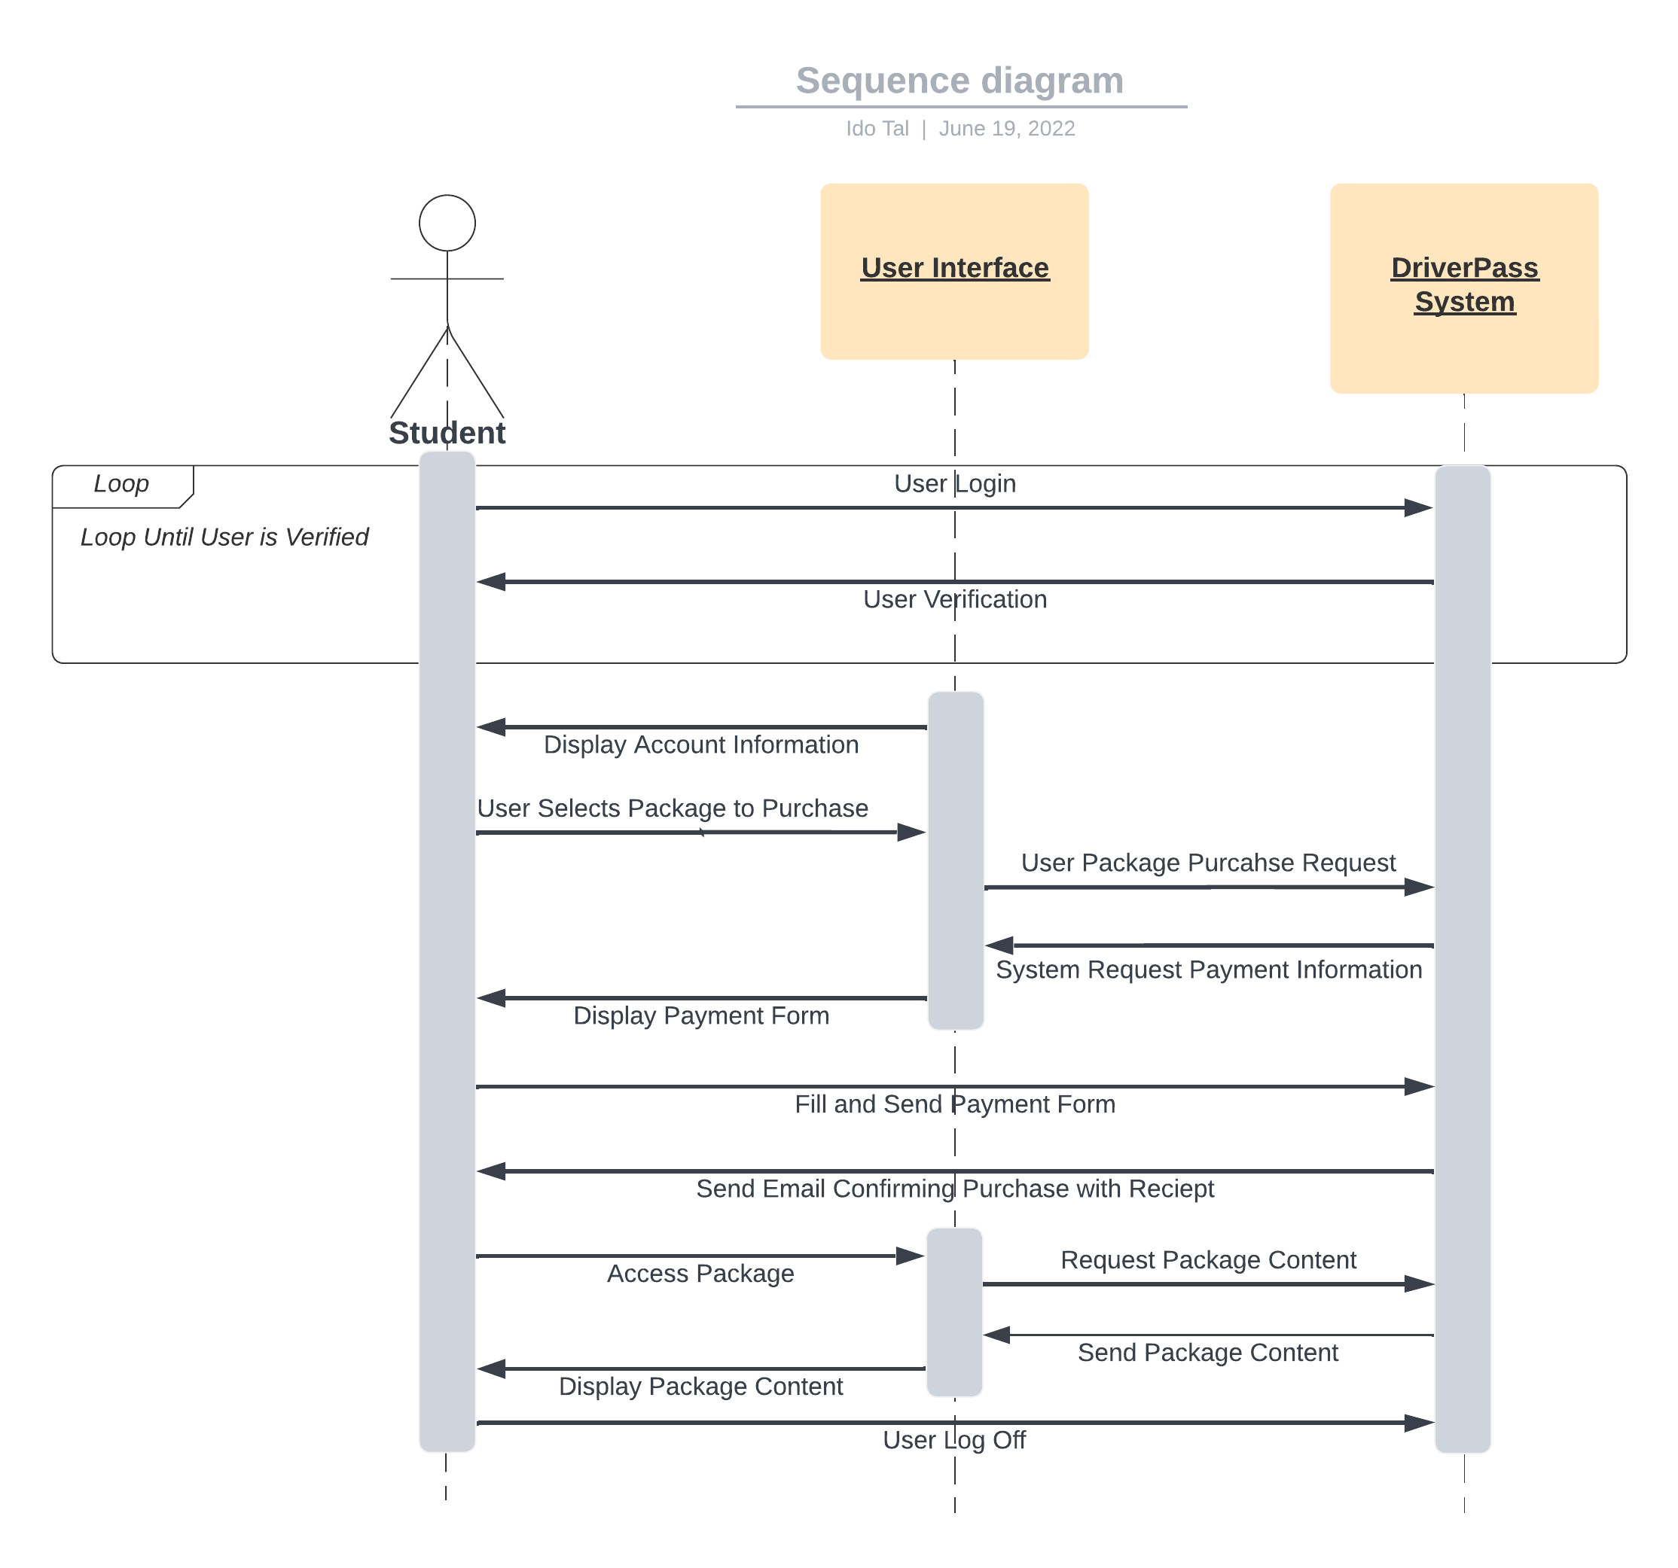

### UML Class Diagram

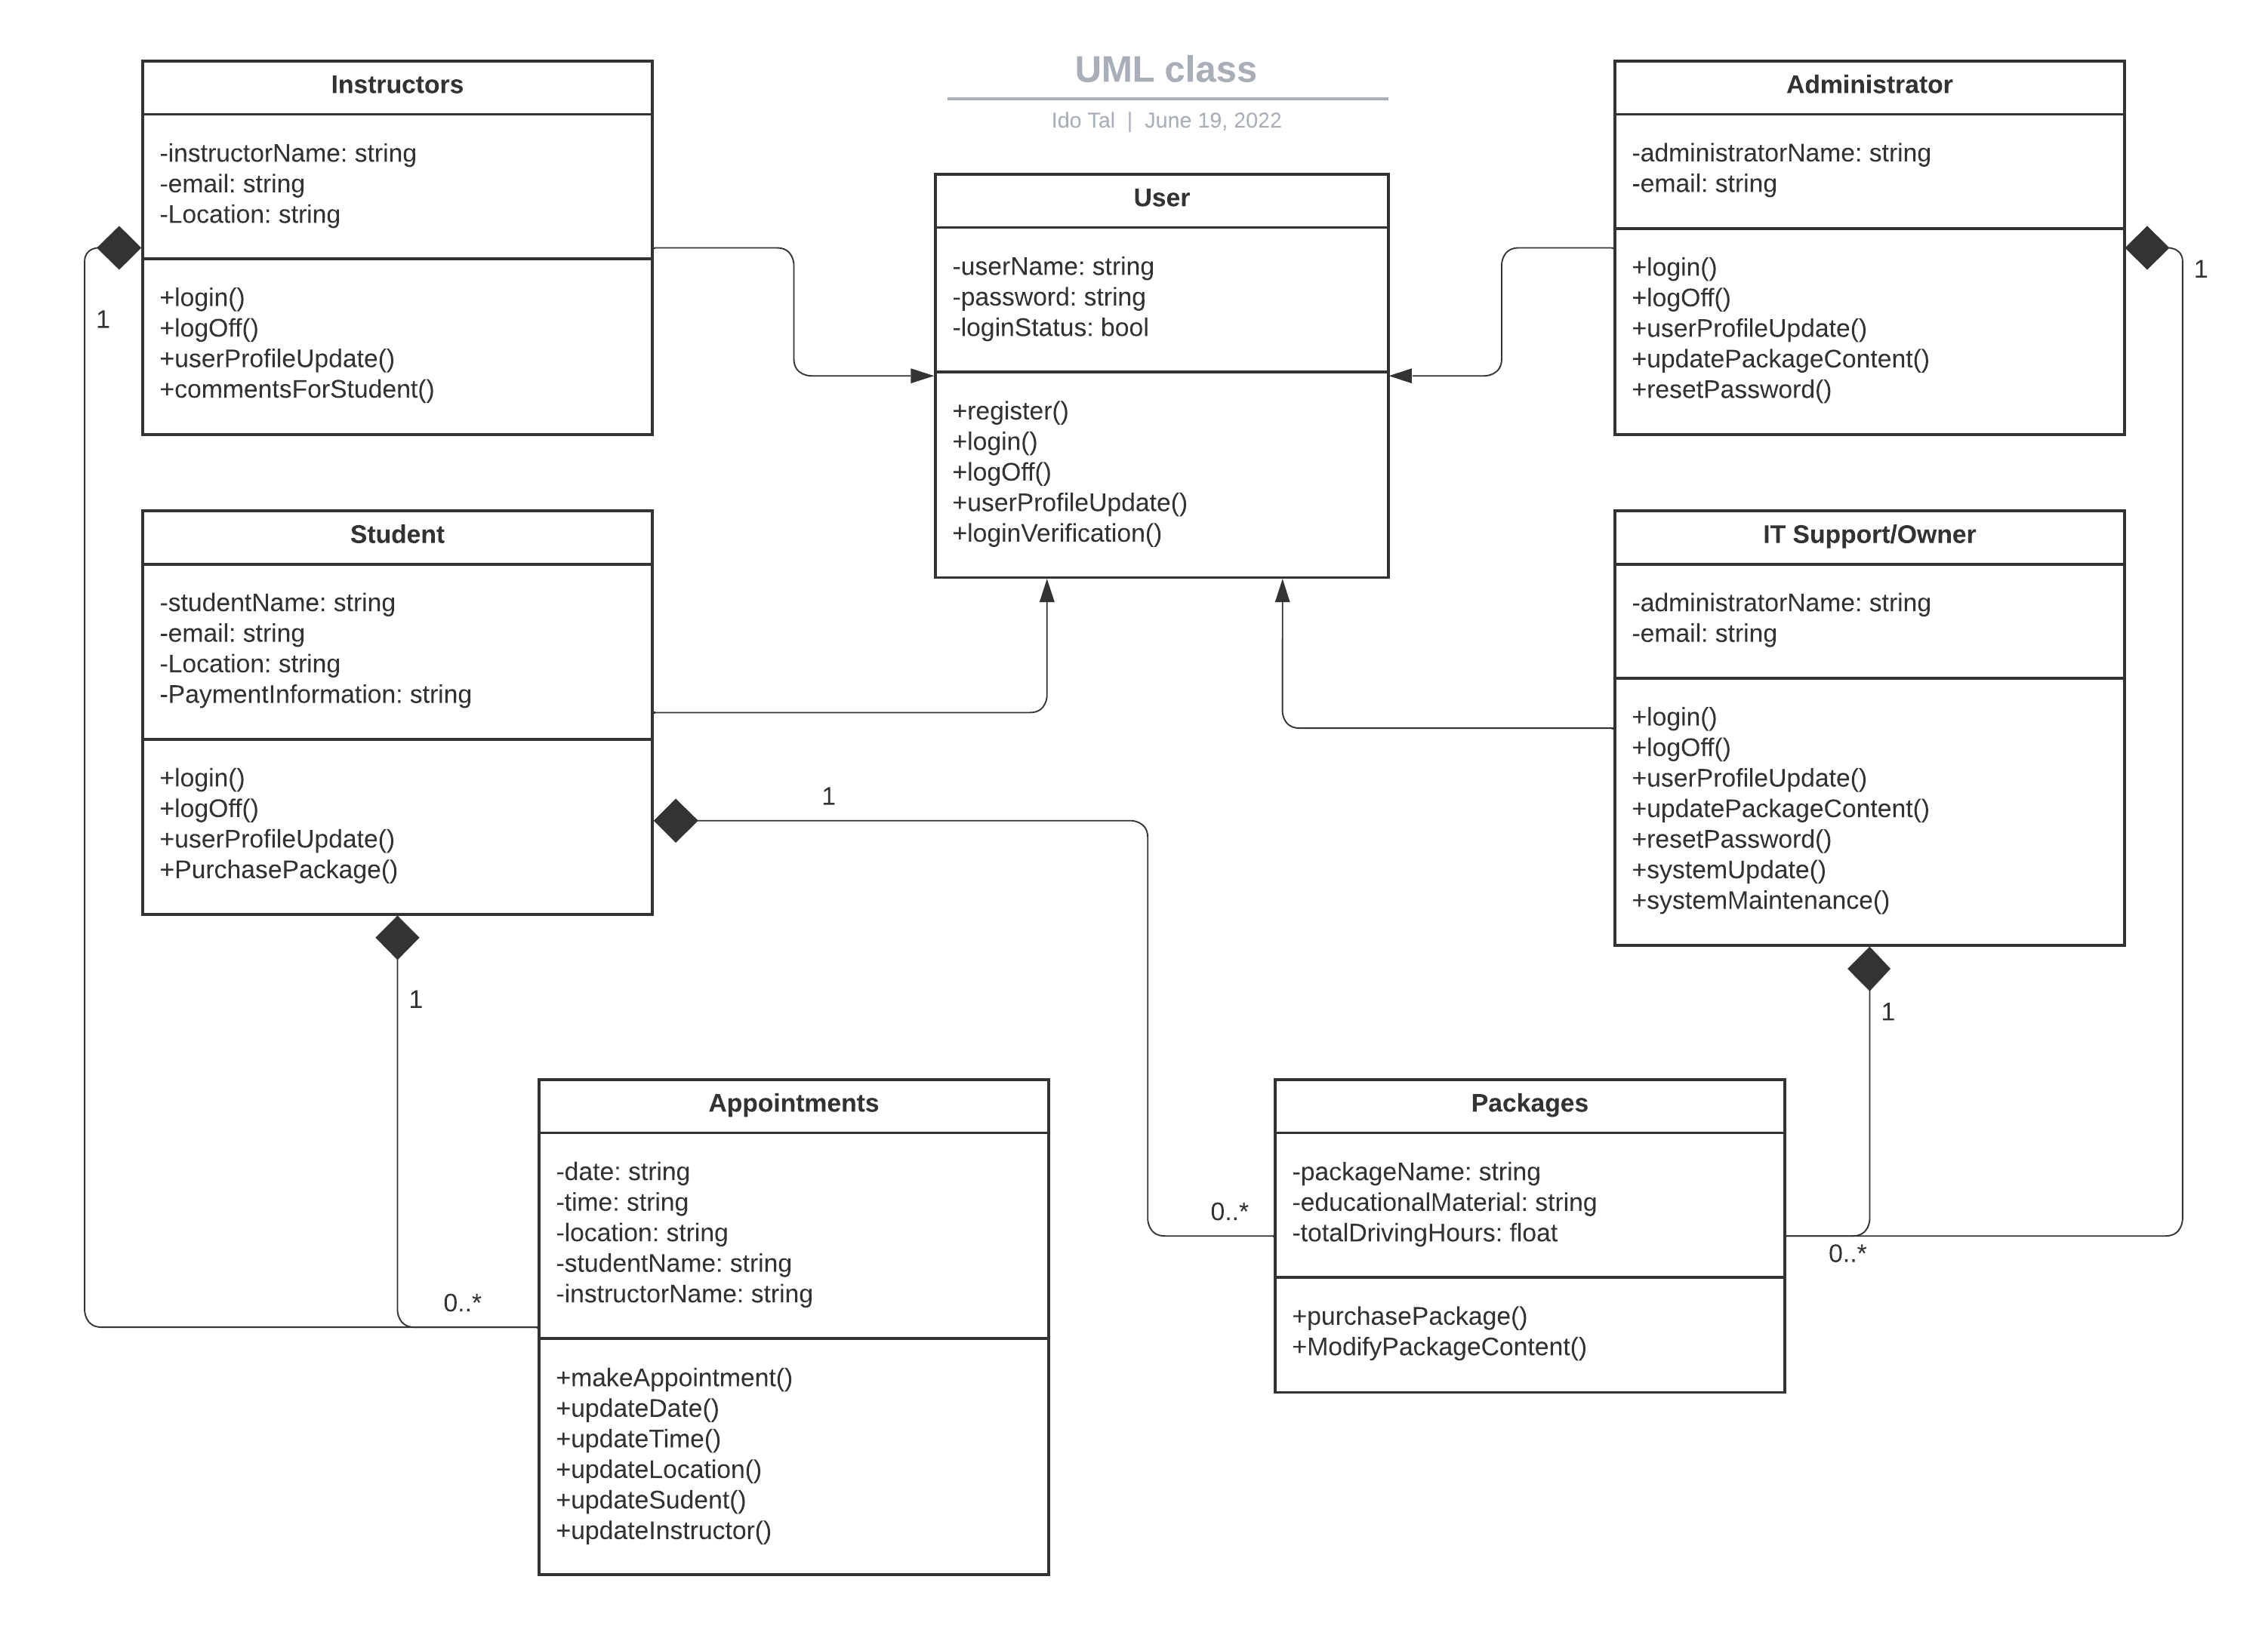

## Technical Requirements

Based on the diagrams that I created, the system will require internet access by all users and by the system. The system needs to have enough storage to hold information about all of the users, their account information, and their appointments. The system needs to have enough capacity to handle all user traffic. Being a web-based service means that users can access the system from any laptop, desktop, phone, or tablet and on any operating system that each device is using. The system requires a well trained IT support who can handle the server that the system is running on, and can make changes to the front end user interface.